PRESS RELEASE

COMMUNICATIONS AND MEDIA TEAM OF THE 2023 ASEAN SUMMIT

No.06/SP/TKM-ASEAN2023/ENG/4/2023

NTT Polda Chief Asks Personnel to Act Humanely when Securing the ASEAN Summit

Kupang, 29 April 2023 – East Nusa Tenggara Regional Police (NTT Polda) Chief Inspector General Johanis Asadoma asked his personnel to always act humanely and kindly to the people in Labuan Bajo, West Manggarai, when securing the 2023 ASEAN Summit.

"Show humanity and friendliness when managing traffic or maintaining security in Labuan Bajo later," he said at the 2023 Komodo Turangga Operation Roll Call to secure the ASEAN Summit at the NTT Police Field, Saturday (29/4/2023).

He gave an example: if people make commotion or disturb public order, the police officers must solve it with a cool head so that it does not cause bickering in the field with the community.

Because of this, the NTT Polda chief asked the NTT Polda and precinct police (polres) ranking personnel assigned to be on the alert during the ASEAN Summit to prepare mentally and physically primed.

The two-star commander also said that in securing the ASEAN Summit, the police's position would only be as the inter-unit support Ring 3 because Ring 1 would be the responsibility of the presidential security detail (paspampres), and Ring 2 would be the national military (TNI).

"That's why I ask that the personnel on standby in Ring 3 must make [problem containment] so that it does not get to Ring 2," he said.

The NTT Regional and the Polres are preparing 1,660 personnel who will begin shifting on Sunday (30/4) using the ferry from Bolok Kupang Harbor to Labuan Bajo.

The selected personnel also, he said, must be prepared to face various things that could disrupt the implementation of the ASEAN Summit, which will take place in a few days.

Furthermore, he also said the deployment of troops carried out by the NTT Regional Police also aims to check all equipment, including personnel and other supporting equipment, to facilitate the ASEAN Summit.

On this occasion, the NTT Polda Chief and several key NTT Polda officials directly checked the vehicles, such as tactical vehicles, that were prepared to go to Labuan Bajo.

Johanis also checked the readiness of the Regional Police personnel and anti-riot troops during the simulation of securing the VVIP guests.

NTT Polda Chief’s appeal

On this occasion, the NTT Polda Chief also appealed to the people in Labuan Bajo, West Manggarai Regency, not to hold demonstrations during the 2023 ASEAN Summit series in that area.

"Of course, this (ASEAN Summit, red) is an honor for all of us NTT people, especially the people of Labuan Bajo, West Manggarai, that this place was directly appointed by the President to be the host, even though the infrastructure facilities are still inadequate," he said.

Because of this, the two-star commander asked all people, especially the people of Labuan Bajo, to refrain from holding demonstrations during the ASEAN Summit, which could damage the reputation of Labuan Bajo itself.

According to him, the Labuan Bajo Community, West Manggarai, needs to be grateful for this. "This is what we have to be grateful for. Let's create a conducive, orderly, friendly security situation, and show that we are good hosts. That's the key," he said.

The number one person in the NTT regional police emphasized that he did not prohibit anyone from demonstrating. However, he appealed for it to be carried out after the ASEAN Summit.

"If there should be demonstrations later, we will determine several points. Please demonstrate, but do not interfere with the comfort of our guests," he added.

Johanis emphasized that the ASEAN Summit meeting in Labuan Bajo would be the pride of the Indonesian people, especially in Labuan Bajo. Apart from that, the ASEAN Summit is an excellent opportunity to promote Labuan Bajo even more massively.

Therefore, the former National Police's International Relations Division Head appealed to the public to refrain from disturbing the guests' security, order, and comfort.

He also estimated that 5,000 people from various ASEAN countries would participate in the 2023 ASEAN Summit in Labuan Bajo, whose peak will take place on May 9-11. (Kornelis Antara/TR/Elvira)

***

For further information, please contact:
Director General of Public Information and Communications of the Ministry of Communications and Informatics – Usman Kansong (0816785320).

Get more information at http://asean2023.id and https://infopublik.id

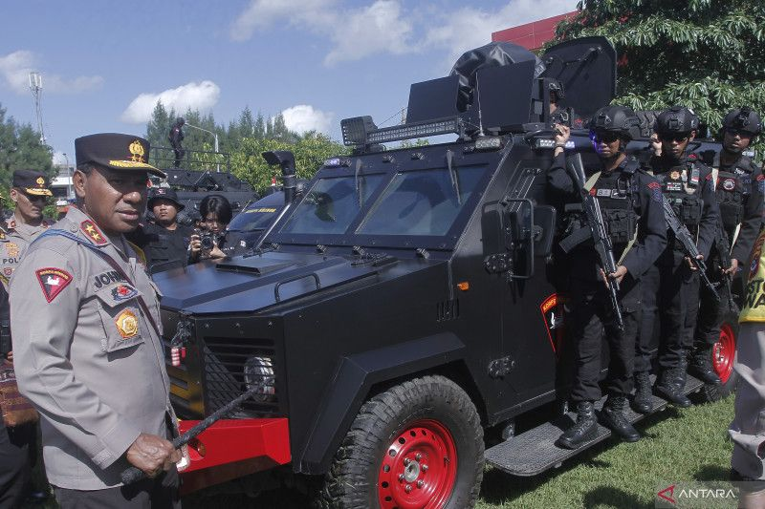

East Nusa Tenggara Regional Police (NTT Polda) Chief Inspector General Johanis Asadoma at the 2023 Komodo Turangga Operation Roll Call for the 2023 ASEAN Summit in Labuan Bajo, West Manggarai District, West Nusa Tenggara, Saturday (29/4/2023). (ANTARA FOTO/Kornelis Kaha).

